**Instituto Politécnico Nacional**

**Escuela Superior de Cómputo**

*Fundamental Analysis of Circuits*

Practice 2: Ohm Law.

Group: 1CV13

Team: 7

Members:

Pastor Martínez Luis Enrique

Partido Terrón Luis Alberto

Pérez Garduño José Emiliano

Maestro:

Raúl Santillán Luna

Practice day: September 11, 2017

Delivery day: September 18,2017

**Index:**

1. Objective
2. Introduction
3. Development
4. Calculations
5. Conclusions

**Objective:**

The student will understand and handle the proper interpretation of Ohm´s law, so at the end of the practice, he will be in possibilities of:

* Calculating voltages, currents, power and resistors that are present in the circuit.
* Comprehend the behavior of the current with respect to the voltage.
* Comprehend the behavior of the current with respect to the resistor.
* Deduct Ohm´s Law.

**Introduction:**

***Ohm Law:*** Ohm's law states that the current through a conductor between two points is directly proportional to the voltage across the two points.

$$I=\frac{V}{R}$$

Where I is the current through the conductors in amperes, V is the voltage measured across the conductor in volts and R is the resistance of the conductor in Ohms. The R in the relation is constant, independent of the current.

The Law was named after de German physicist Georg Ohm, who in 1827 described measurements of applied voltage and current trough simple electrical circuits containing different lengths of wires.

Ohm did his work on resistance in the years 1825 and 1826, and published his results in 1827 as the book Die galvanische Kette, mathematics bearbeitet ("The galvanic circuit investigated mathematically"). He drew considerable inspiration from Fourier's work on heat conduction in the theoretical explanation of his work. For experiments, he initially used voltaic piles, but later used a thermocouple as this provided a more stable voltage source in terms of internal resistance and constant voltage. He used a galvanometer to measure current, and knew that the voltage between the thermocouple terminals was proportional to the junction temperature. He then added test wires of varying length, diameter, and material to complete the circuit. He found that his data could be modeled through the equation:

$$x=\frac{a}{b+l´}$$

Where x was the reading from the galvanometer, l was the length of the test conductor, a depended only on the thermocouple junction temperature, and b was a constant of the entire setup. From this, Ohm determined his law of proportionality and published his results.

The most common formulas used in circuit analysis are:

$I=\frac{V}{R}$ $V=IR$ $R=\frac{V}{I}$

***Voltage:*** Voltage is electric potential energy per unit charge, measured in joules per coulomb (volts). It is often referred to as "electric potential", which then must be distinguished from electric potential energy by noting that the "potential" is a "per-unit-charge" quantity. Like mechanical potential energy, the zero of potential can be chosen at any point, so the difference in voltage is the quantity which is physically meaningful.

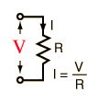When describing voltage, current, and resistance, a common analogy is a water tank. In this analogy, charge is represented by the water amount, voltage is represented by the water pressure, and current is represented by the water flow. So, for this analogy, remember:

Water = Charge

Used to calculate current in Ohm´s Law

Pressure = Voltage

***Electric Current:*** Electric current is the rate of charge flow past a given point in an electric circuit, measured in Coulombs/second which is named Amperes. In most DC electric circuits, it can be assumed that the resistance to current flow is a constant so that the current in the circuit is related to voltage and resistance by Ohm's law. The standard abbreviations for the units are 1 A = 1C/s.

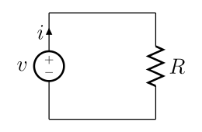

***Electric Power:*** The electric power in watts associated with a complete electric circuit or a circuit component represents the rate at which energy is converted from the electrical energy of the moving charges to some other form, e.g., heat, mechanical energy, or energy stored in electric fields or magnetic fields. For a resistor in a D C Circuit the power is given by the product of applied voltage and the electric current:

$$P=VI$$

Where P is power measured in watts, V is voltage and I is intensity of the current in amperes.

***Electrical Resistance:*** The electrical resistance of an electrical conductor is a measure of the difficulty to pass an electric current through that conductor. The inverse quantity is electrical conductance, and is the ease with which an electric current pass. Electrical resistance shares some conceptual parallels with the notion of mechanical friction.

$$R=\frac{V}{I}$$

**Development:**

Without turning on the power supply, set the value of the potentiometer to 2.5KΩ. Arm the circuit illustrated in figure 1 on the protoboard. Once armed, turn on the power supply and vary its value from 0 to 15 V, like it´s asked in table 1.

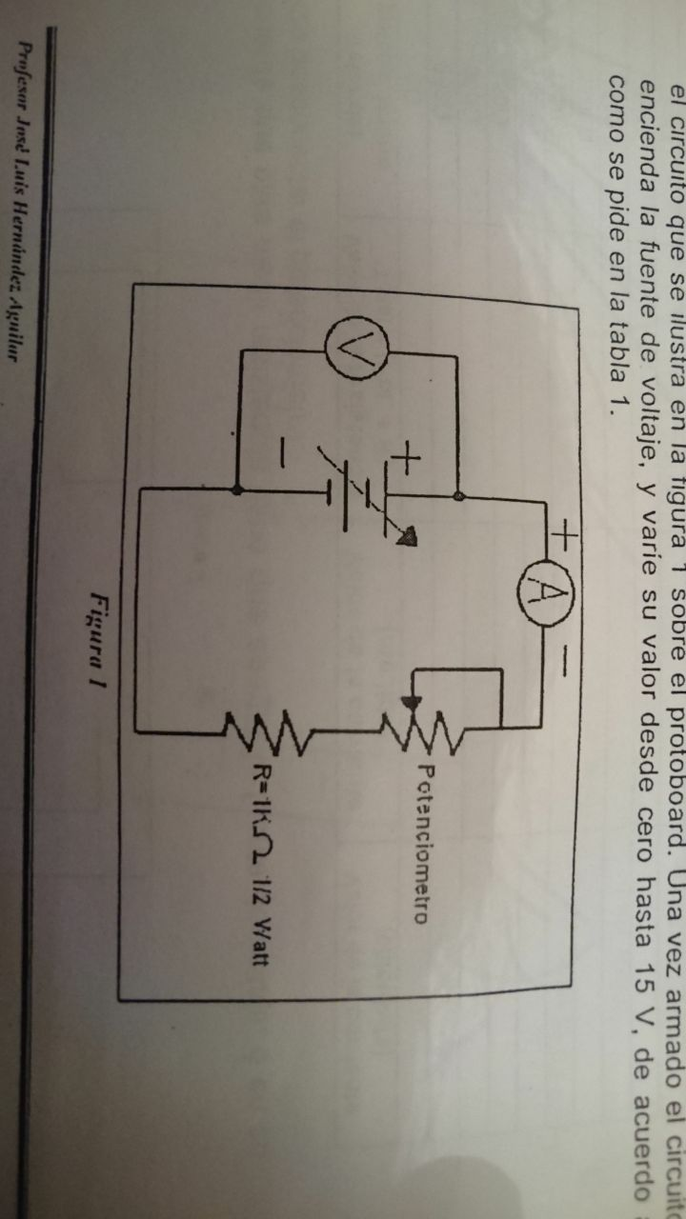

|  |  |  |
| --- | --- | --- |
| Power Supply (V) | Value of the current (measured) | Value of the current (calculated) |
| 0 | 0A | 0A |
| 1 | 0.27mA | 0.285mA |
| 2 | 0.52mA | 0.571mA |
| 3 | 0.76mA | 0.85mA |
| 4 | 1.03mA | 1.14mA |
| 5 | 1.28mA | 1.42mA |
| 6 | 1.54mA | 1.71mA |
| 7 | 1.8mA | 2mA |
| 8 | 2.03mA | 2.28mA |
| 9 | 2.3mA | 2.57mA |
| 10 | 2.56mA | 2.85mA |
| 11 | 2.79mA | 3.14mA |
| 12 | 3.05mA | 3.42mA |
| 13 | 3.31mA | 3.71mA |
| 14 | 3.56mA | 4mA |
| 15 | 3.83mA | 4.28mA |

|  |  |
| --- | --- |
| Power supply (V) | Simulation |
| 0 |  |
| 1 |  |
| 2 |  |
| 3 |  |
| 4 |  |
| 5 |  |
| 6 |  |
| 7 |  |
| 8 |  |
| 9 |  |
| 10 |  |
| 11 |  |
| 12 |  |
| 13 |  |
| 14 |  |
| 15 |  |

With the last table, and with the values obtained of current (measured) trace the next table:

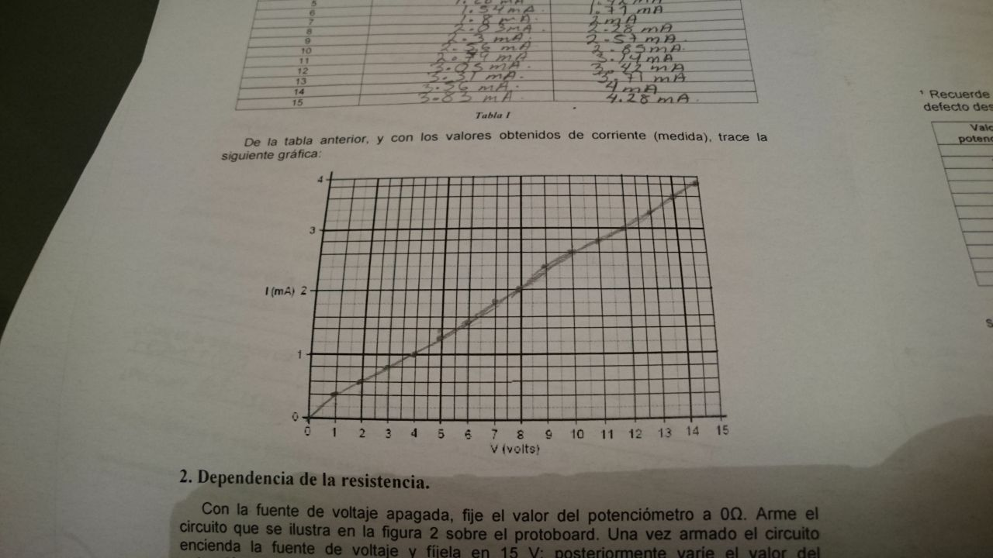

2. Dependency of the resistor.

With the power supply turned off, set the value of the potentiometer to 0Ω. Arm the circuit illustrated in figure 2 over the protoboard. Once it´s armed, turn on the power supply and set it to 15V; later vary the value of the potentiometer like its asked in the next table.

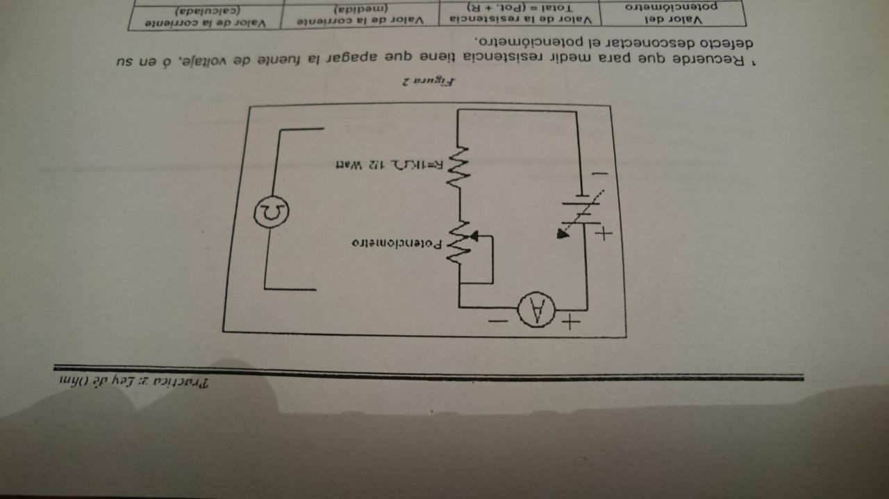

|  |  |  |  |
| --- | --- | --- | --- |
| Value of the potentiometer | Value of the resistance  Total = (Pot + R) | Value of the current (measured)(mA) | Value of the current (calculated)(mA) |
| 0 Ω | 1000 Ω | 14.9 | 15 |
| 250 Ω | 1250 Ω | 12.14 | 12 |
| 500 Ω | 1500 Ω | 10.1 | 10 |
| 750 Ω | 1750 Ω | 8.4 | 8.57 |
| 1000 Ω | 2000 Ω | 7.3 | 7.5 |
| 1250 Ω | 2250 Ω | 6.57 | 6.66 |
| 1500 Ω | 2500 Ω | 5.9 | 6 |
| 1750 Ω | 2750 Ω | 5.4 | 5.45 |
| 2000 Ω | 3000 Ω | 4.8 | 5 |
| 2250 Ω | 3250 Ω | 4.4 | 4.61 |
| 2500 Ω | 3500 Ω | 4.1 | 4.2 |

|  |  |
| --- | --- |
| Value of the potentiometer | Simulation |
| 0 Ω |  |
| 250 Ω |  |
| 500 Ω |  |
| 750 Ω |  |
| 1000 Ω |  |
| 1250 Ω |  |
| 1500 Ω |  |
| 1750 Ω |  |
| 2000 Ω |  |
| 2250 Ω |  |
| 2500 Ω |  |

From the last table and with the values obtained of current (measured), trace the next graph.

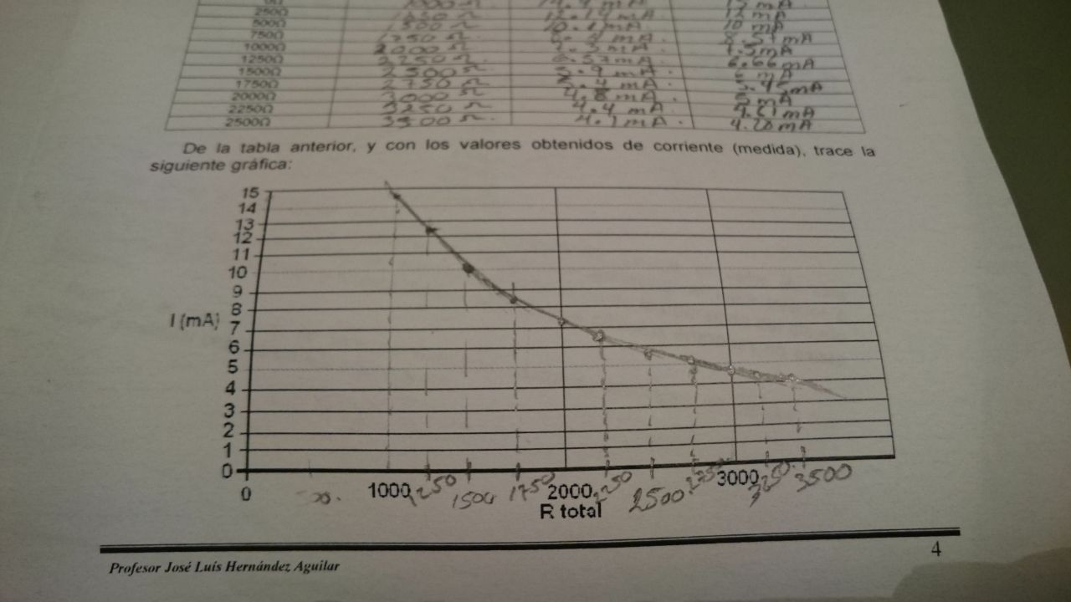

3. Calculus of the power in the resistors.

Before connecting the power supply, we have to set it to 1 volt, later turn it off and without utilizing the protoboard, arm the circuit illustrated in figure 3, for this circuit use the resistance of 1KΩ to ¼ of Watt, one it´s armed turn on the power supply.

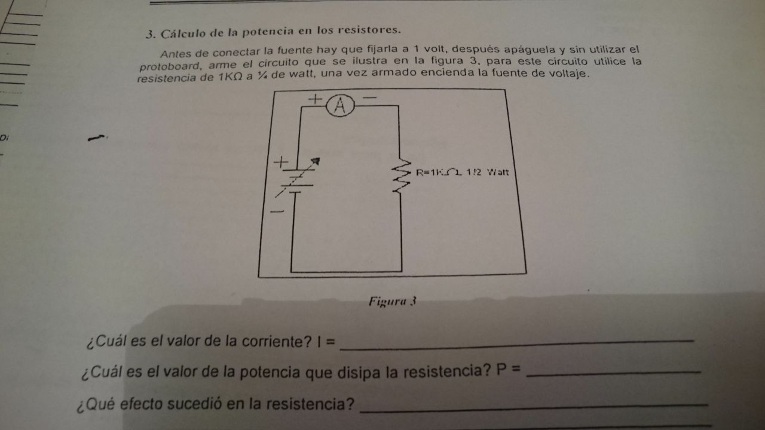

Which is the value of the current?

I = 0.95mA.

Which Is the value of the power that dissipates the resistor?   
P = 1 mWatt

What effect happened in the resistor?

None.

Why?

Because it´s within the range of power it can support.

Again, arm the last circuit but now using de 1Ω to 1-Watt resistor, before connecting the power supply be sure to set it to 1 volt and that de Amperemeter is set to the maximum scale.

Which is the value of the current?

I = 1 A

Which is the value of the power that dissipates the resistor?

P = 1 Watt.

What effect happened to the resistor?

It dissipated heat.

Which is the difference to the last circuit?

That the power required is greater.

Why?

Because the range of support is less than needed.

|  |  |
| --- | --- |
| Value of the resistance | Simulation |
| 1KΩ |  |
| 1Ω |  |

Calculations:

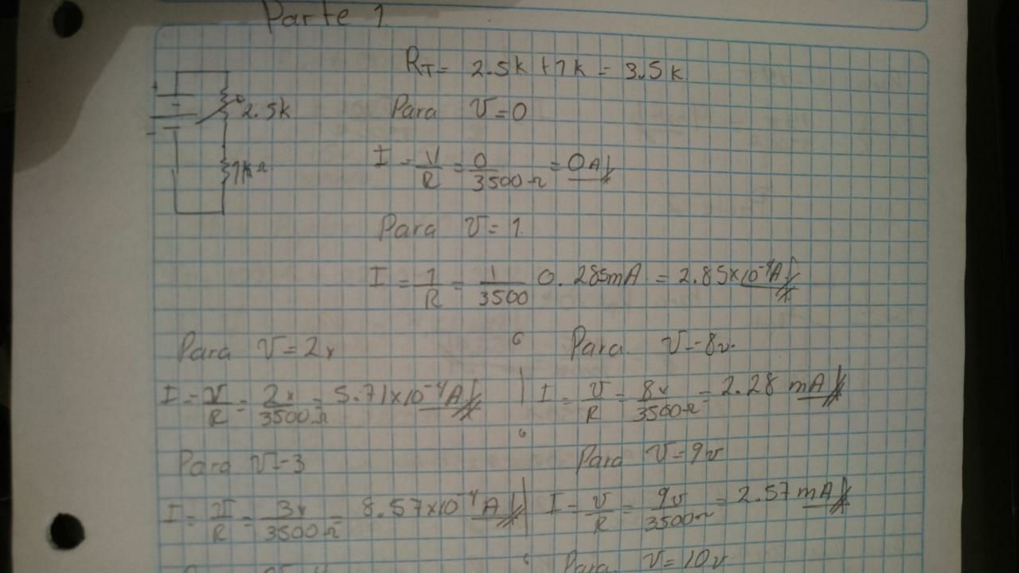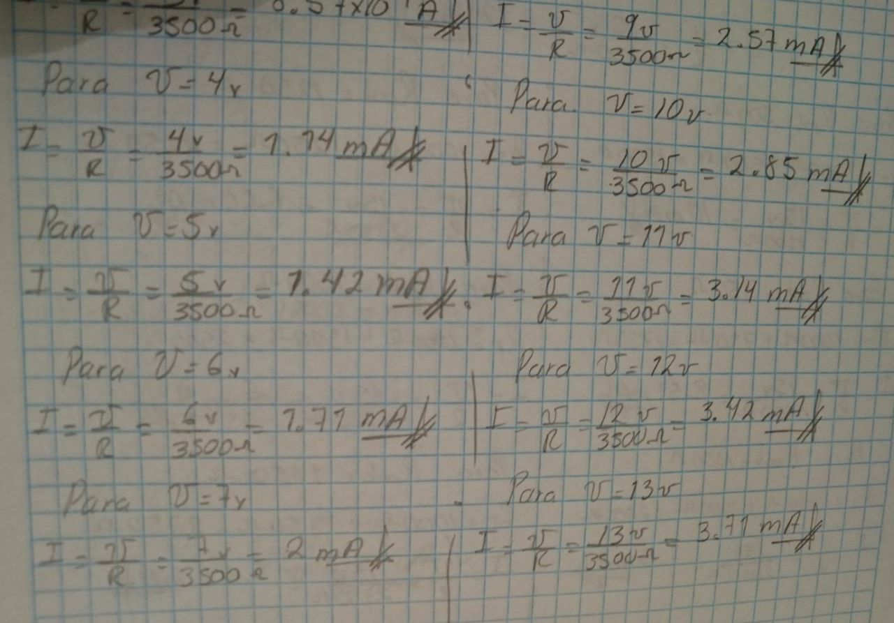

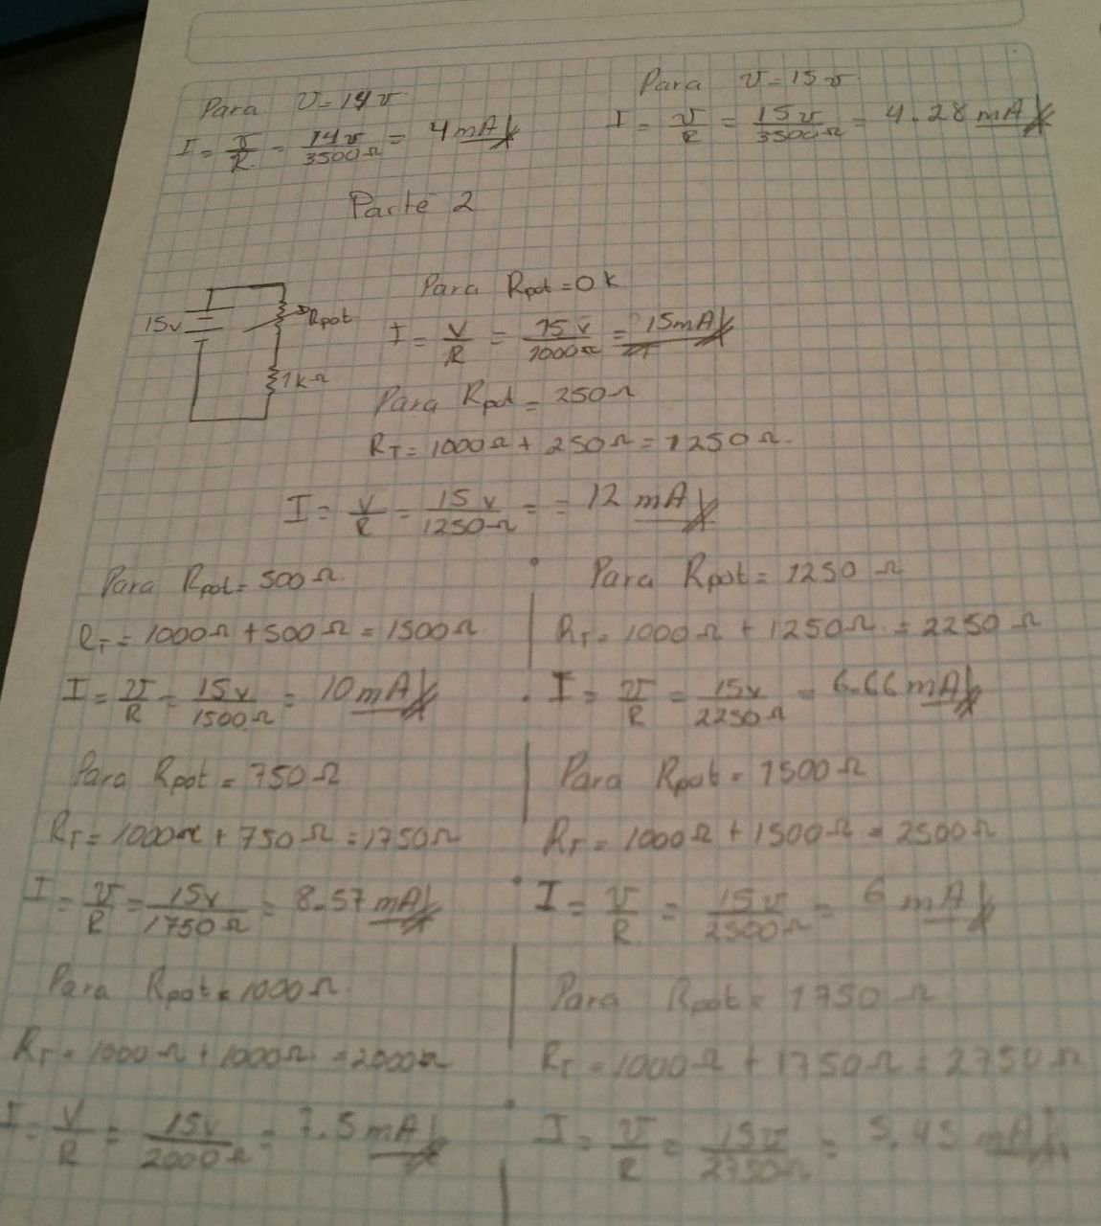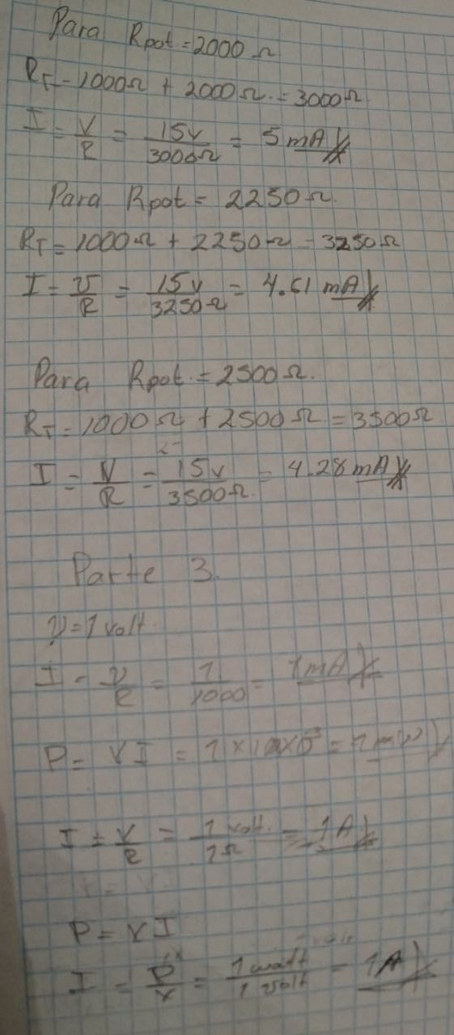

**Conclusions:**

Luis Enrique: This practice shows us the behavior of the electric current when we can have control of a variable resistance. It also proves that the current and resistance are inversely proportional.

Luis Alberto: The first practice is important because we understand the use of the elements as passive and active, also the interaction between these elements.

José Emiliano: We learned to use Ohm´s law and how we can take advantage from it to calculate the different exercises presented in the practice, how if we vary the voltage, the current changes in the resistors and the same with the potentiometer which we also learned to use.